**Speech**

For this activity, we are going to teach our new friends to speak. This is very simple and you can have them saying any sentence you wish, and even have two or more sprites have conversations with each other!

Let’s start by clicking on the looks tab and dragging the ‘Say’ block over into the script area.

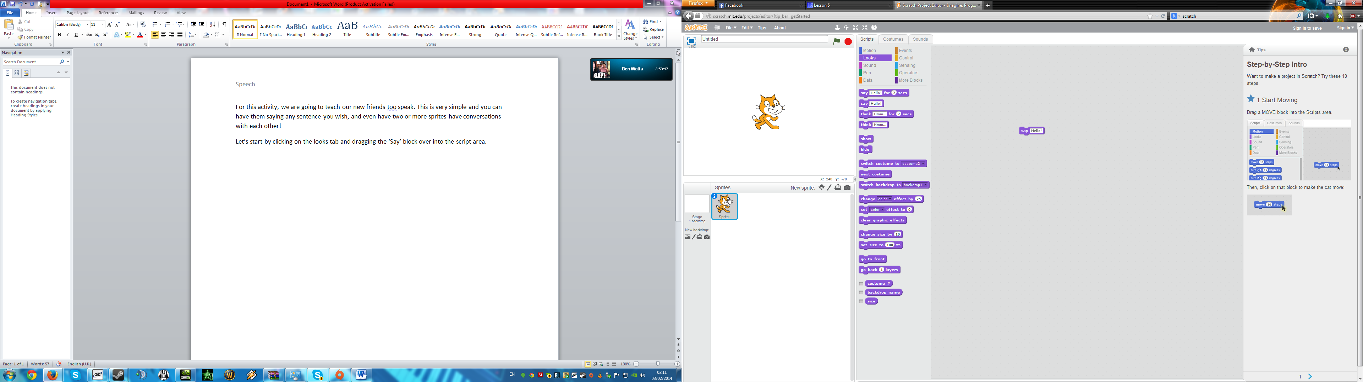

Now, feel free to type anything you wish into the box. When you have finished this, start your programme.   
  
**Tip:** If your programme doesn’t work, have you remembered to put 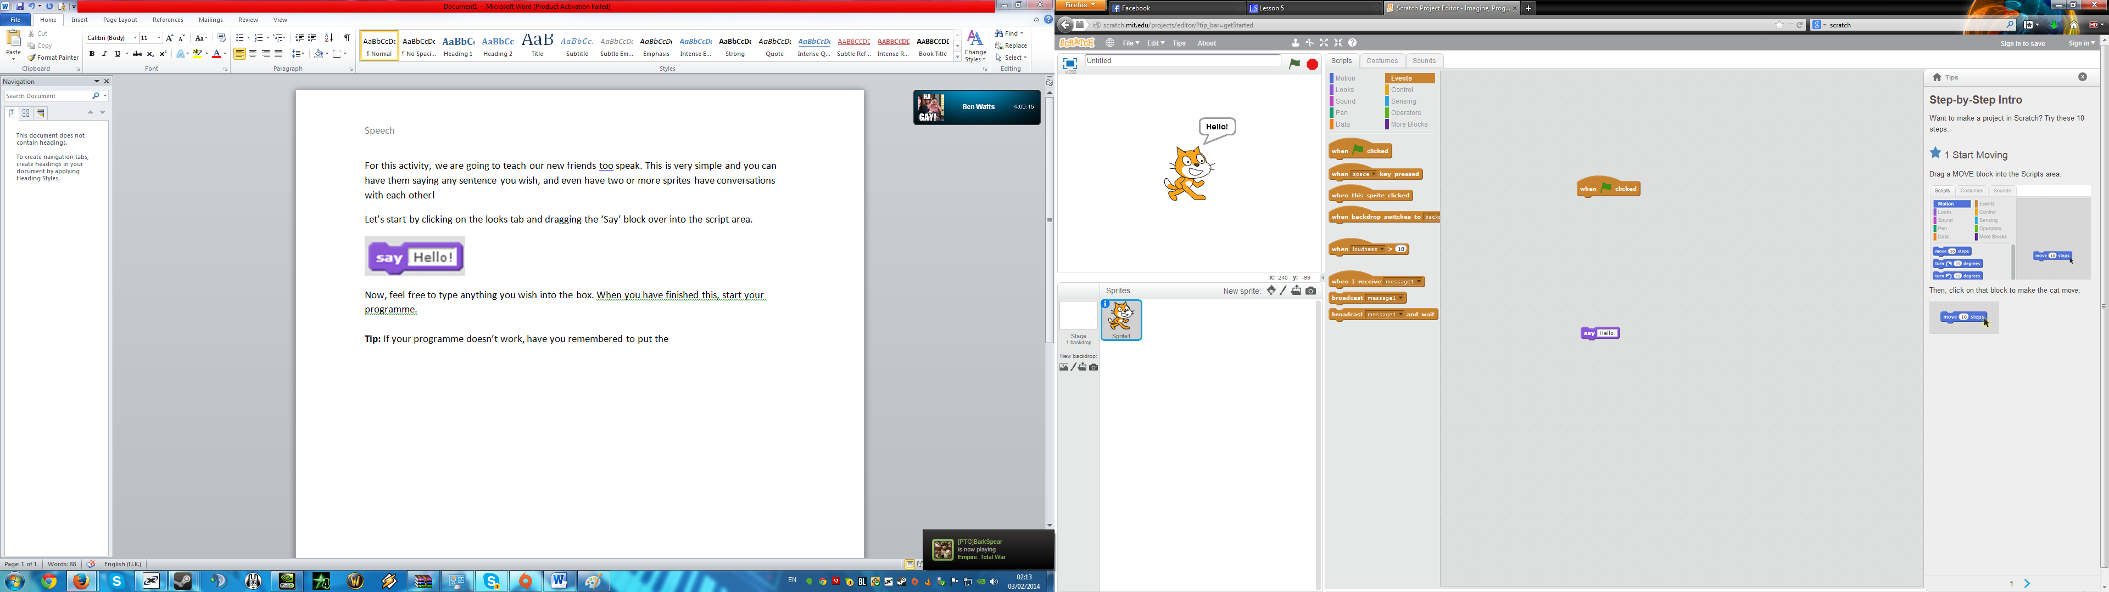 into your programme?

**Task:** Explain the difference between the ‘say’ block and the ‘think’ block when the animation is played.  
  
_______________________________________________________________________________  
  
_______________________________________________________________________________

Next we are going to work on the blocks which have ‘for # seconds’. Unlike our previous blocks, these ones allow the sprite to say something only for a certain amount of time. A really good trick when you become used to these functions is animating two sprites to have a conversation with each other!

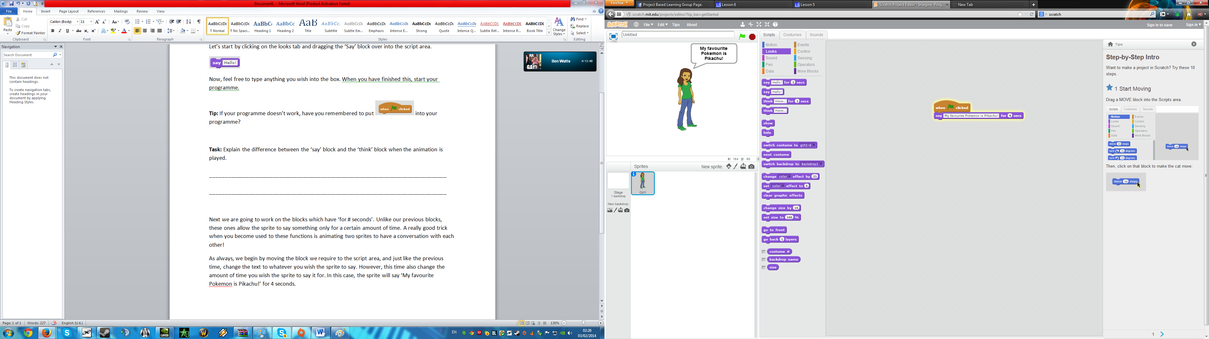

As always, we begin by moving the block we require to the script area, and just like the previous time, change the text to whatever you wish the sprite to say. However, this time also change the amount of time you wish the sprite to say it for. In this case, the sprite will say ‘My favourite Pokemon is Pikachu!’ for 4 seconds.

**Task:** Create a programme which will have your sprite say something, wait for a certain amount of time, and then say something else.

**Advanced Task:** Create a programme in which two sprites appear to be having a conversation at the same time.  
  
**Hint:** You will need to use: 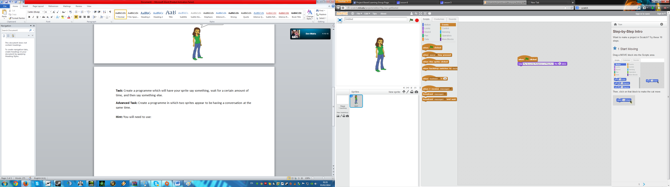  
**Hint:** Scripts can be used more than once in a programme.

**Effects**Inside the looks tab, you will see a script which looks like this:  
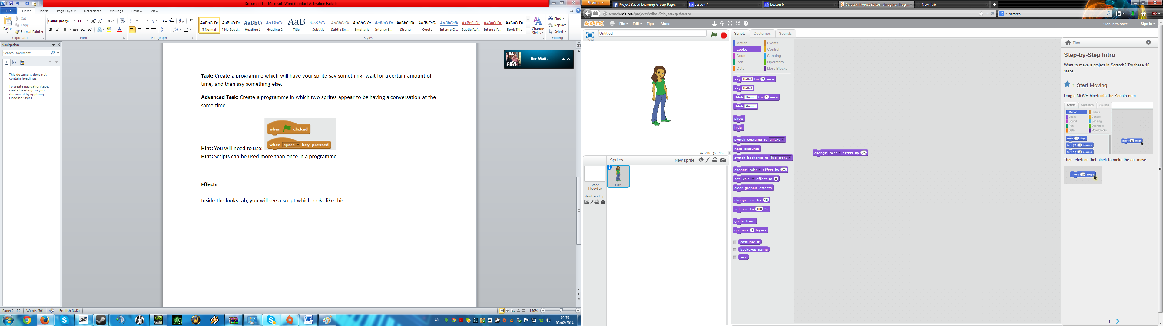

Using the dropdown box, you will see there are many different options such as ‘colour’, ‘whirl’, ‘pixelate’ and so on. Select the one you wish and press run, you will notice that something will be different with your sprite.  
  
**Task:** Experiment with the different types of effects and see which ones you like the most  
  
__________________________________________________________________________________  
  
__________________________________________________________________________________

**__________________________________________________________________________________Audio**Is your programme missing something? We know how to make it colourful with a background, we know how to add sprites into our image, we know how to make them talk and move about, but we don’t know how to make sounds in our programme yet? Well, not yet we don’t.

Adding sounds into your programme is very easy. All you have to do is go into the ‘Sounds’ tab at the top of the screen, here you will see a selection of the sounds you have in your programme. The list now is empty, however we are going to change this. Click on the button which looks like a speaker, and import which ever sound file you wish your programme to make. Remember to test your chosen file by clicking the play button!

Now, go back into the scripts tab, go to the ‘Sound’ block and move the ‘Play sound’ block to your script area. Add it to the rest of your programme from before. Does it work? If so congratulations! You now have your first fully functional programme! You’re on your way to becoming a master!